**Project 1**

<RPSLS>  
(rock paper scissors lizard spock)

CSC5-40375  
David Ballantyne  
02/11/14

**Introduction**

Title: RPSLS

RPSLS is a modified game based off of the original Rock Paper Scissors usually played by two people, where players simultaneously form one of five shapes with an outstretched hand. The game was invented by the sitcom ‘The Big Bang Theory’.

**Summary**

Project size: 290 lines

The number of variables: 9

I originally intended to make an easy or hard level for just an ordinary rock paper scissors game I spent time reading about ‘Sicilian Reasoning’ but failed to put the concept and code together. I then fell behind on time and so I needed to come up with a quick solution for to achieve most of the requirements for project 2. I decided to add a structure with a static array inside, the same as what we’ve been doing for LAB the past few days. I decided to use that array to keep score using a DAT file. After I got bored with the same simplicity of the game so as a quick fix I decided to change rock paper scissors to RPSLS to add the difficulty of choice instead. Procrastination is not a healthy habit.

**Description**  
RPSLS a game made for those who push their luck. Are you confident in your choices? A 40% chance of victory in every play, do have what it takes to be undefeated? Or are you just a regular cut among the rest? Test yourself in this game of providence!  
  
 **Flow Chart**  
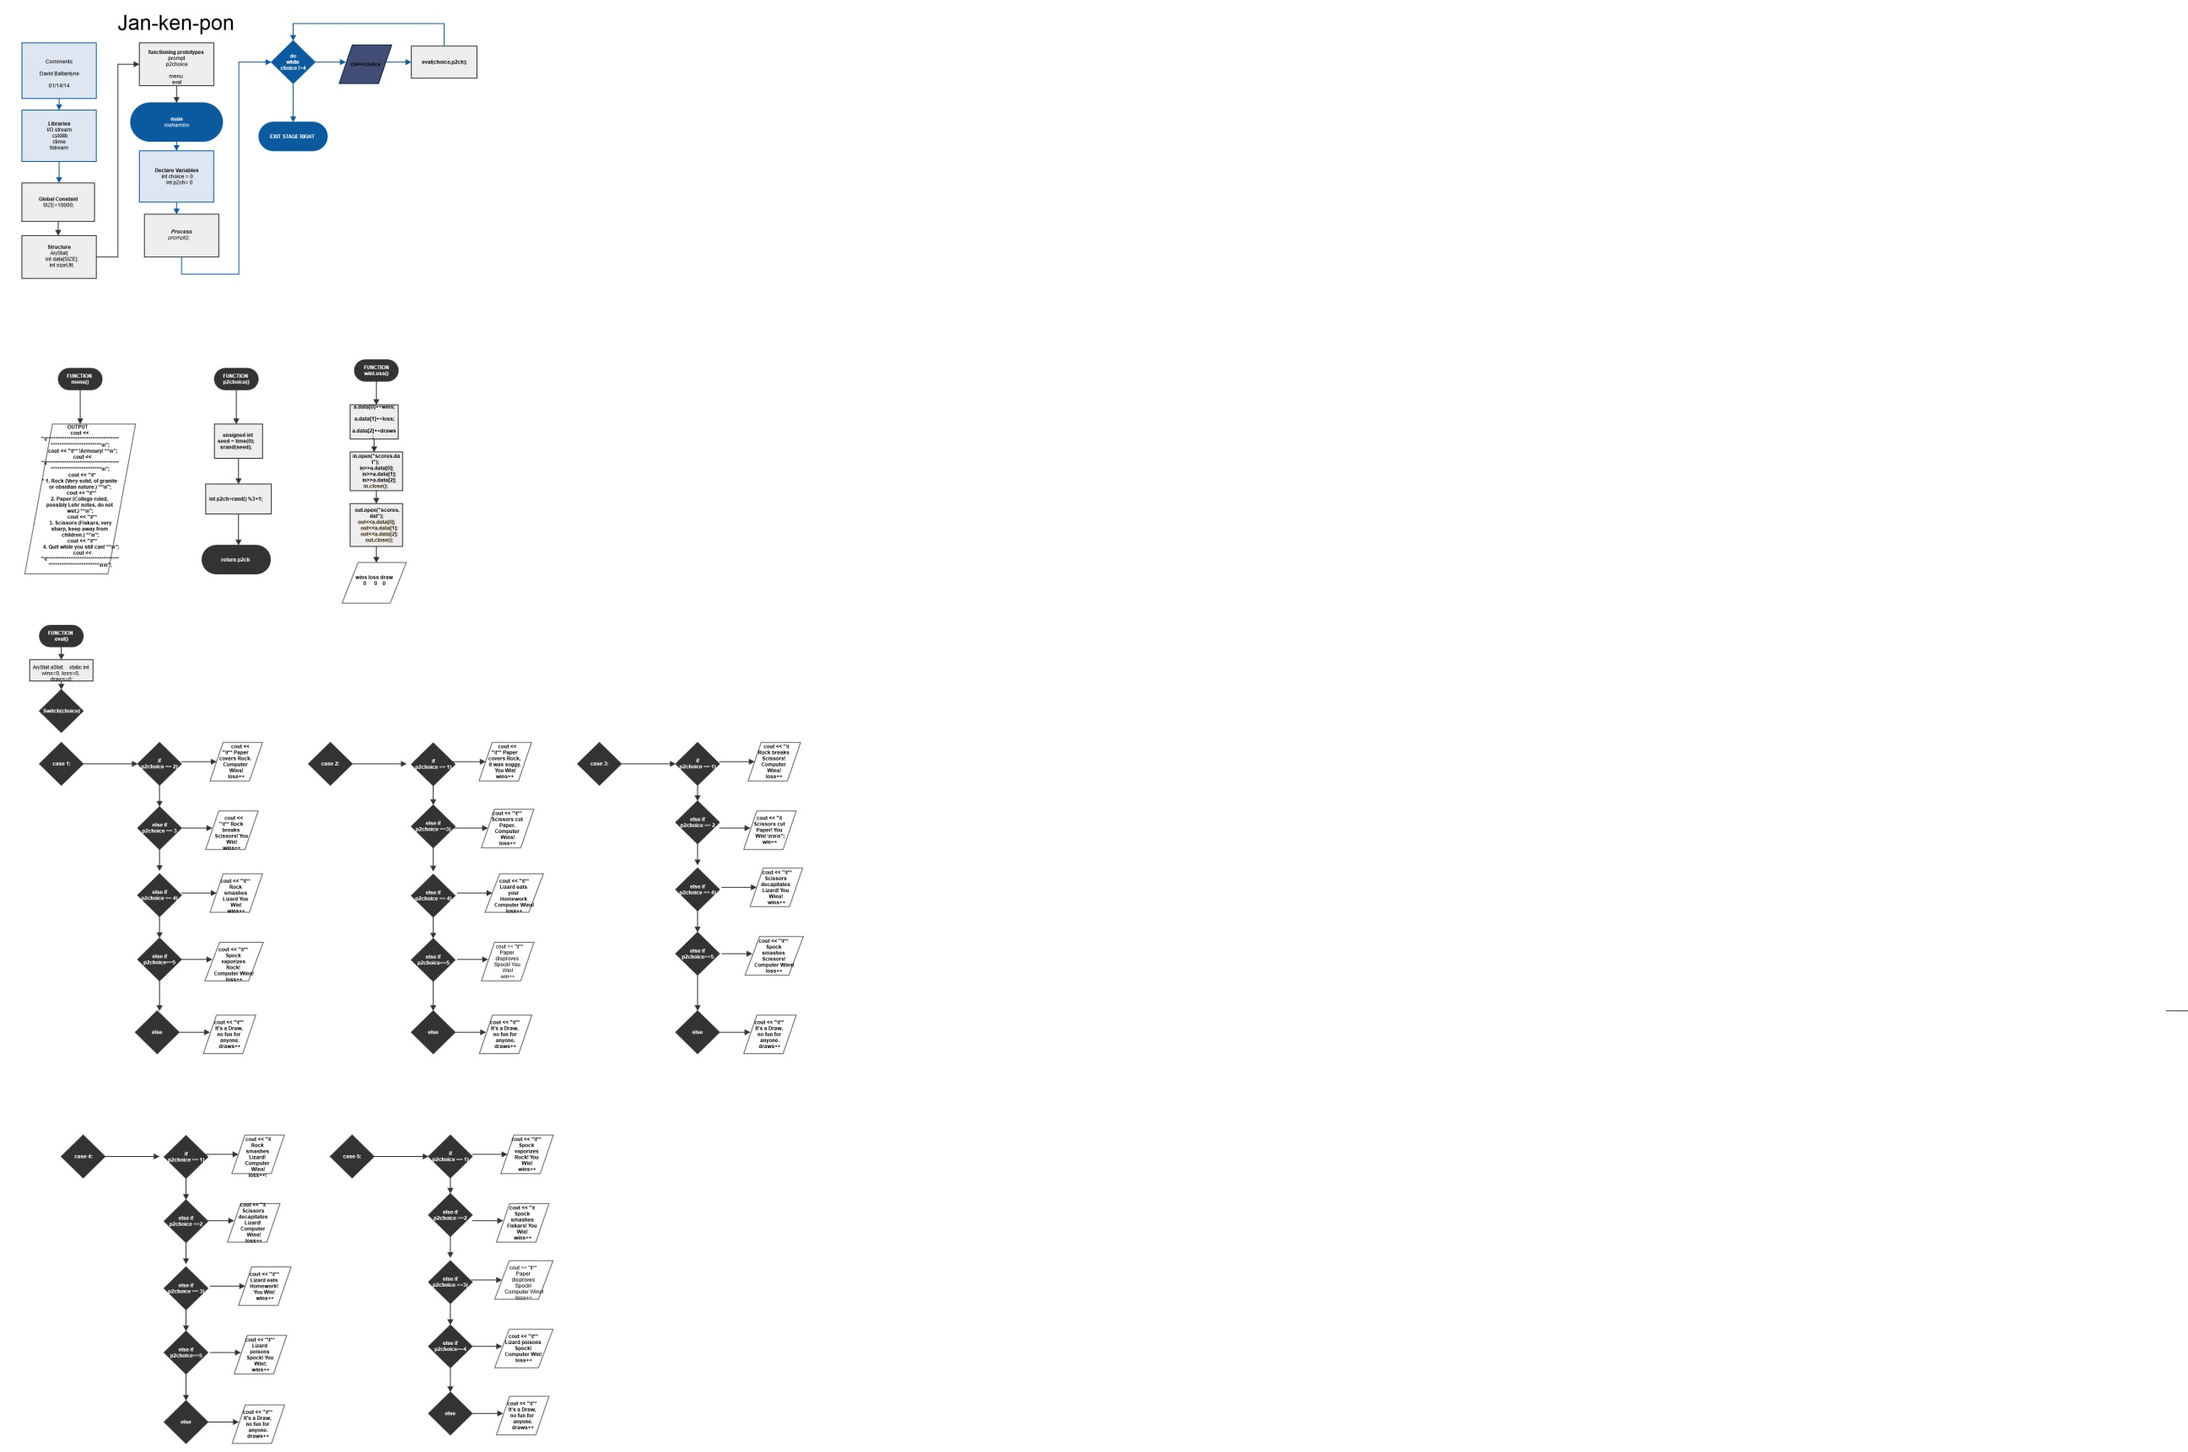

*(note jpg included with project folder)*

***Pseudo Code:***

*Execution begins here*

*Player one default*

*Player two default*

*Display prompt()*

*Do*

*P2choice()*

*set random number seed*

*mod rand to return value 1, 2, 3, 4, or 5*

*return the value*

*Display choice options menu()*

*Input user choice*

*Run evaluation function eval()*

*Switch to user input choice*

*Determine if output is win loss or tie*

*input and output wins loss and draws using winLoss()*

*While user input is not equal to 6*

*Exit Stage Right*

|  |  |  |  |
| --- | --- | --- | --- |
| **Type** | **Name** | **Location** | **Description** |
| int | choice | main, eval(int,int) | Player 1's rock paper scissor option |
|  | p2ch | main, eval(int, int) | p2choice()'s return integer |
| unsigned | seed | p2choice() | an unsigned variable to set random number seed |
| Static int | Wins  loss  draws | eval(int, int) | Counts wins losses and draws for user |
| Static array | aStat | eval(int, int) | Array used to count scores and read and write from a file |

|  |  |  |  |  |
| --- | --- | --- | --- | --- |
| **Loop** | **Location** | **Purpose** | **Gaddis Chapter** |  |
| Switch | eval() Function | to determine user choice | Ch4, pgs. 202-209; |  |
| Do While | main | To exit or continue Game | Ch5, pgs. 242-246,262; |  |
| If | eval() Function | to determine Output | Ch4, pgs 154-165; |  |
| If/else | eval() Function | to determine Output | Ch4, pgs. 166-168,176-180; |  |
| else | eval() Function | to determine Output | Ch4, pgs.167,177-179; |  |

**Reference**  
1.textbook

2.LAB assignments